1.

1. 11
2. 16
3. 4
4. No, it is not possible as a digraph is a graph with directed edges and this graph does not have directed edges

Question 1e) and 1f) and 2 are done separately on another pdf file

3.

|  |  |  |  |
| --- | --- | --- | --- |
|  | | Predicted label: | |
| Positive | Negative |
| Actual label: | Positive | 30 | 30 |
| Negative | 20 | 20 |

1. Classifier R:

Accuracy= 30+20/100 = 50%

Recall = 30/(30+30) = 50%

Precision = 30/(30+20) = 60%

f-measure = (2*0.6*0.5)/(0.6+0.5) = 0.55

|  |  |  |  |
| --- | --- | --- | --- |
|  | | Predicted label: | |
| Positive | Negative |
| Actual label: | Positive | 60 | 40 |
| Negative | 0 | 0 |

1. Classifier B:

Accuracy= 60/100 = 60%

Recall = 60/(60+40) = 60%

Precision = 60/(60+0) = 100%

f-measure = (2*0.6*1)/(0.6+1) = 0.75

1. Classifier A:

Accuracy= (35+25)/100= 60%

Recall = 35/(35+25) = 58%

Precision = 35/(35+15) = 70%

f-measure = (2*0.58*0.7)/(0.58+0.7) = 0.63

1. The best classifier is B because it has the highest f-measure

4)

1. SELECT customer_lastname, customer_firstname

FROM Tableorders

ORDER by customer_lastname;

1. SELECT name from Table products

WHERE (Table products.product_id = Table orders_contents.product_id)

AND (Table orders_contents.kg_bought >= 0.6);

1. SELECT order_id, name, kg_bought, price_kg, (kg_bought*price_kg) “item_price”

FROM Table products, Table orders_contents

ORDER by order_id;

5)

1. Visibility: How easy it is for the user to find what he/she wants

Affordances: The actions the user can perform through the system

Signifiers: Signs that tell the user how the system works

Constraints: Restrictions on what the user can do

Mappings: Relationship of controls to their effects

Feedback: Reactions from the system due to user actions

Consistency: Using the similar concepts for similar operations

1. 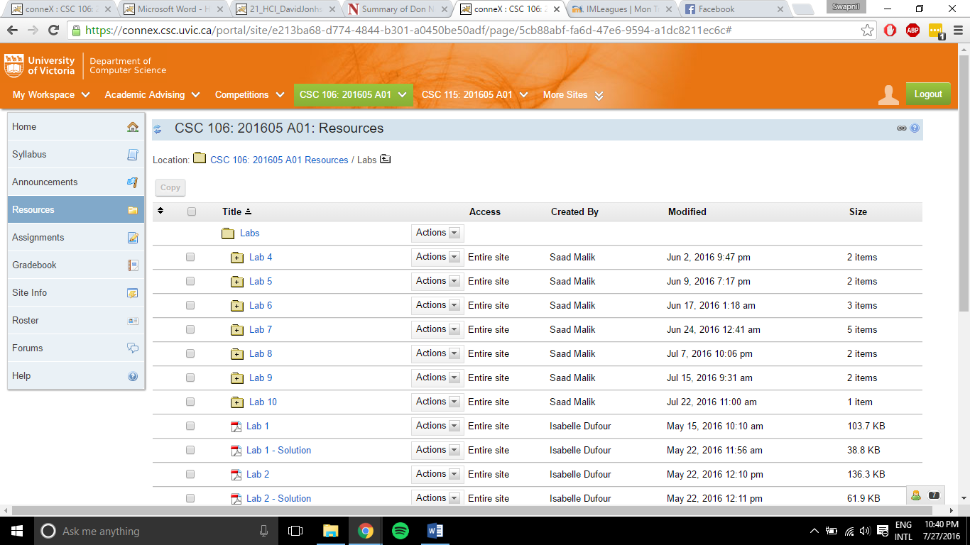Focus on visibility on connex website:

In this example, we cannot easily see how we can navigate back to the previous folder in the resources tab. The function to do this can be found as shown, however it is not very clear that is used to do the case thus is not very effective. Furthermore, the symbol itself is very ambiguous as to what it actually does.

1. A cognitive walk-through is simply trying to put yourself in the mind of the reader and see how he would use and interact with the system. The best way to achieve this is by constantly asking yourself these questions:
2. Will users know what to do next to complete the task?
3. Will they know what controls to use?
4. Will they know if the controls produced the right effect?
5. Will the users understand they did the correct thing from the feedback they received?